Study Skills

We have gathered some helpful study tips to help our students feel organised and motivated in preparation for the November exam which are fast approaching. There are many different factors to consider on the path to becoming a successful student. The most important factors are:

- Goal Setting
- Organisation and Time Management
- Overcoming Study Blocks.

Goal Setting

Goals help inspire and motivate you. Set 2 or 3 goals for yourself before you study each day. For example

- I will cover the following sections….
- At the end of one hour I will know…
- I will study one chapter of…
- I will strive to improve my grade in….
- I will finish my English essay by 6pm on Sunday
- I will study for one hour on Saturday before dinner.

Remember getting started is always the most difficult step. To help you get started pick realistic and specific goals. 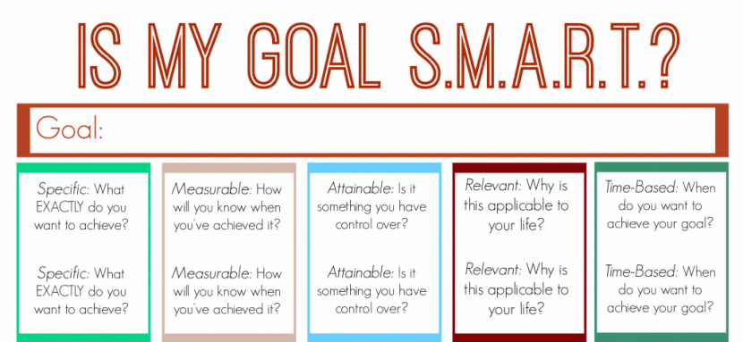

Organisation and Time Management

An organised approach to your studies will mean that you will have to work a little less over the coming year. With better organisation you will be on top of things from day one and you won’t have to cram at exam time or the dreaded night before the exam. For example:

- Study Materials: study planner, the correct books, the right stationery including highlighters, different coloured pens and flash cards etc.
- Create a daily or weekly plan. We have attached a sample study plan for you to download and use at home. This will help you keep track of time and helps you prioritise subjects and help you to procrastinate less. Click here to download your free study plan.

Overcome Study Blocks

Talk to someone

Study can feel like a very overwhelming task. Remember, no matter what the barrier you can get through it. It is important that if you are feeling anxious and stressed about the upcoming exams to chat with a parent, teacher or friend. Discuss your biggest study blocks and work out how to remove these distractions from your daily routine.

Take breaks
Going for a quick run or walk before you settle down to study or taking a break from study can help you clear your head and stay focused.

Rest Up
A good night’s sleep can work wonders. With a good night’s sleep you will find it easier to recall facts and figures the next day. All the learning you do is transferred to your long-term memory as you sleep. Each night your brain processed the day’s thoughts and actions, so in the lead up to your exams you need at least eight hours rest a night.

Proper Nutrition
A healthy diet is always important, especially during your exams. It is important to stay away from junk food. Crisps and fizzy drinks are the worst option for an energy boost. They provide a quick release, but afterwards you’ll crash - leaving you worse off than before. It is better to choose foods like nuts, bananas, carrots and popcorn instead. Eating the right carbohydrates before an exam may help you feel more relaxed and less anxious such as wholegrain breads, brown pasta and cereals, raspberries and sweet potatoes. Proteins will also help keep you alert such as milk, dried beans, eggs and fish.

