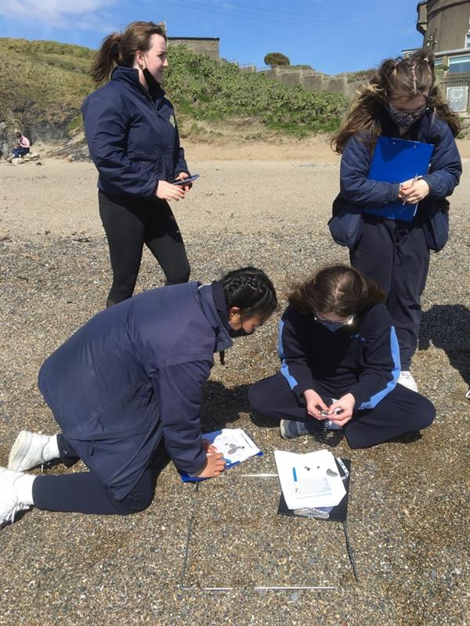

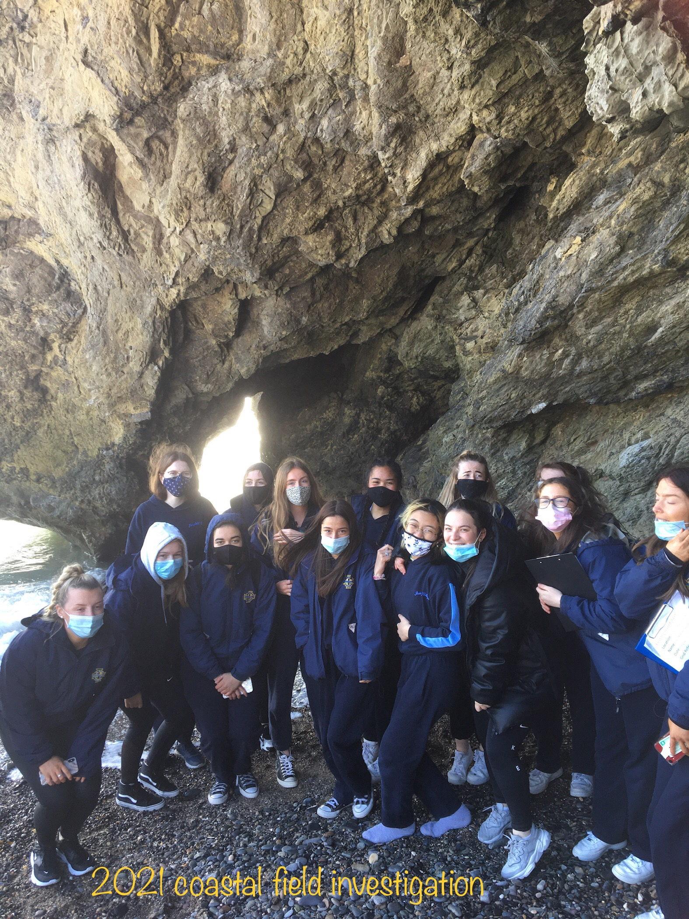

Beach Gradient

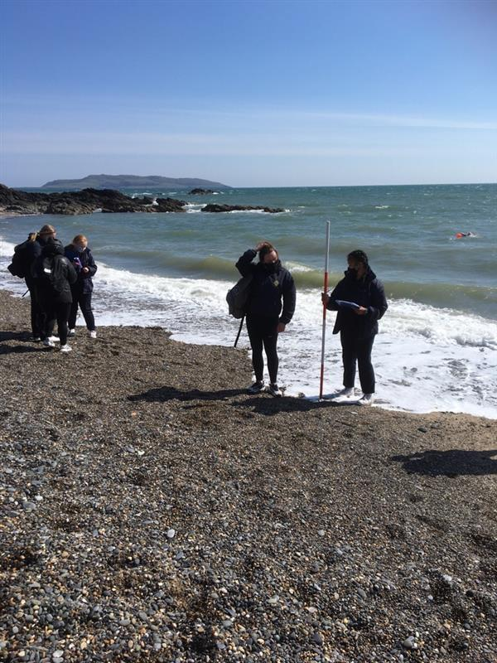



Sketch map

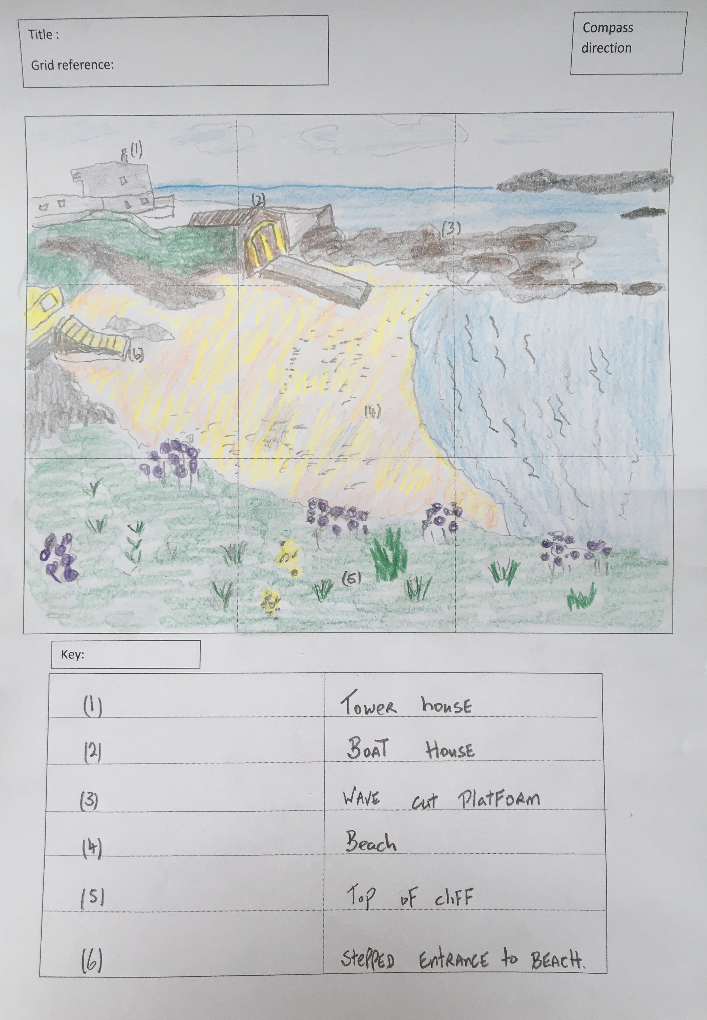

Measurement of cliff height

2021 field investigation was carried out after lockdown . Our chosen site was Tower Bay Beach, Portrane Co. Dublin . The aim of investigation was to examine two processes of erosion in shaping the coastal landscape .

arch

stack

cave

stump

Bay

Cliff

Wave cut Platform

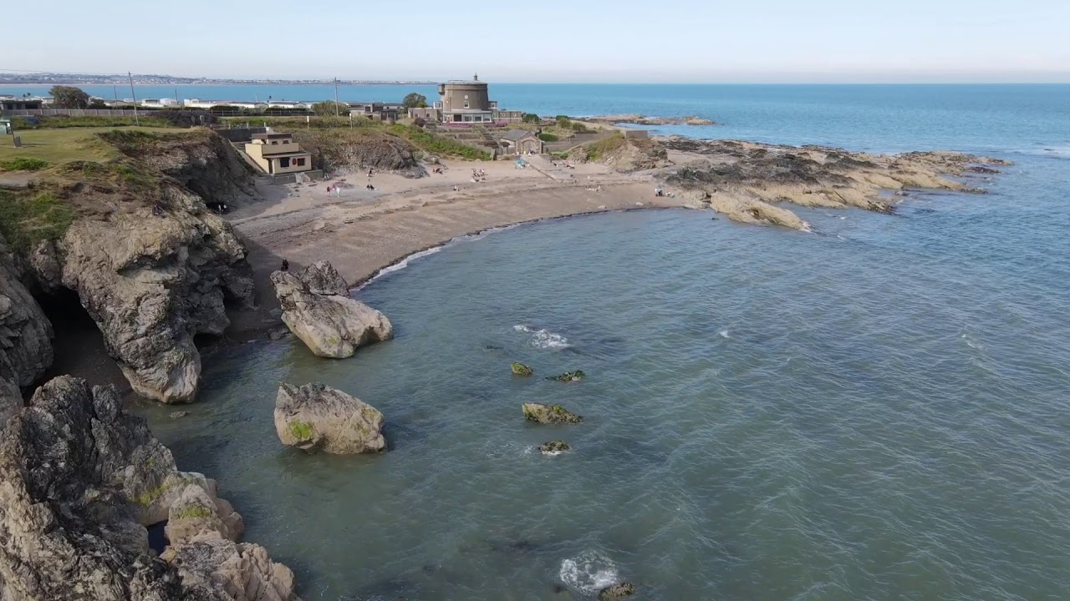

Wave Count



