Steps to set up MFA on your o365 Account

- Before you begin.. download Microsoft Authenticator App to your phone
- Open up any browser... and go to https://www.office.com and click Sign In

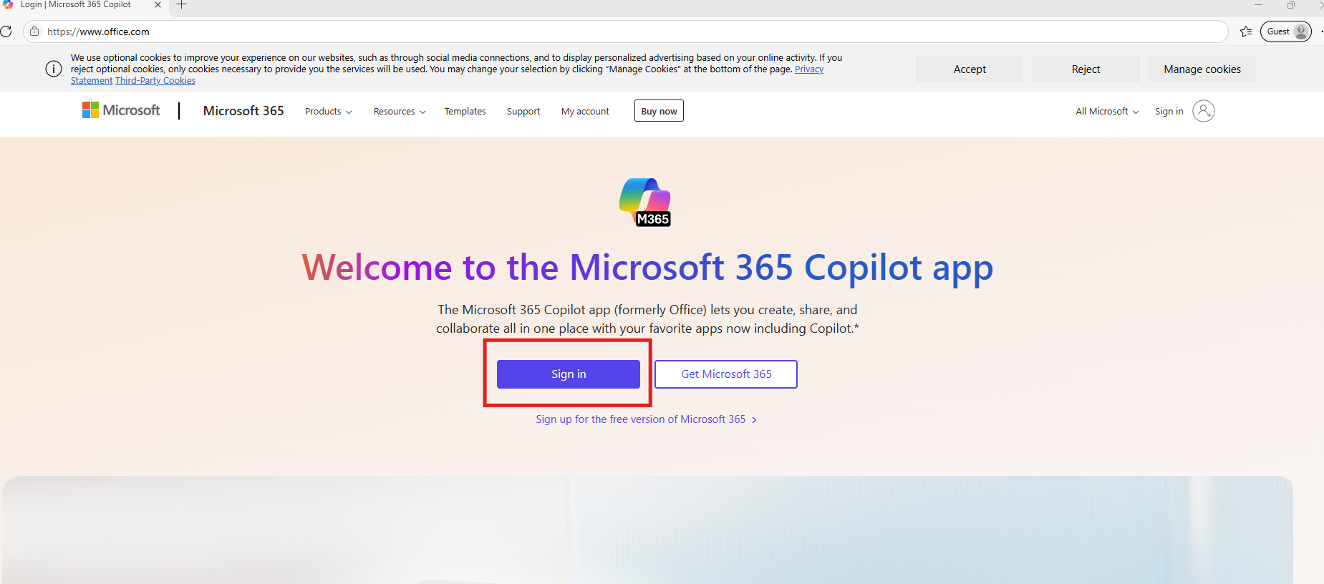

- Sign in to your o365 account.

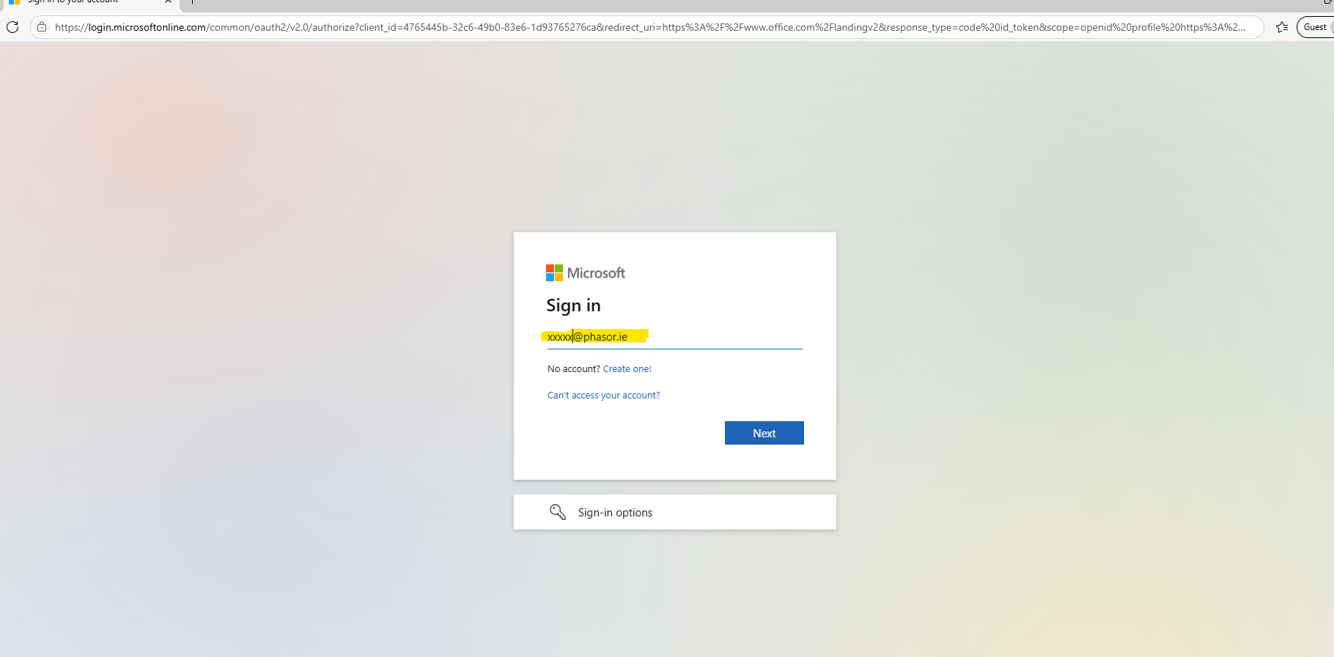

- Enter your password

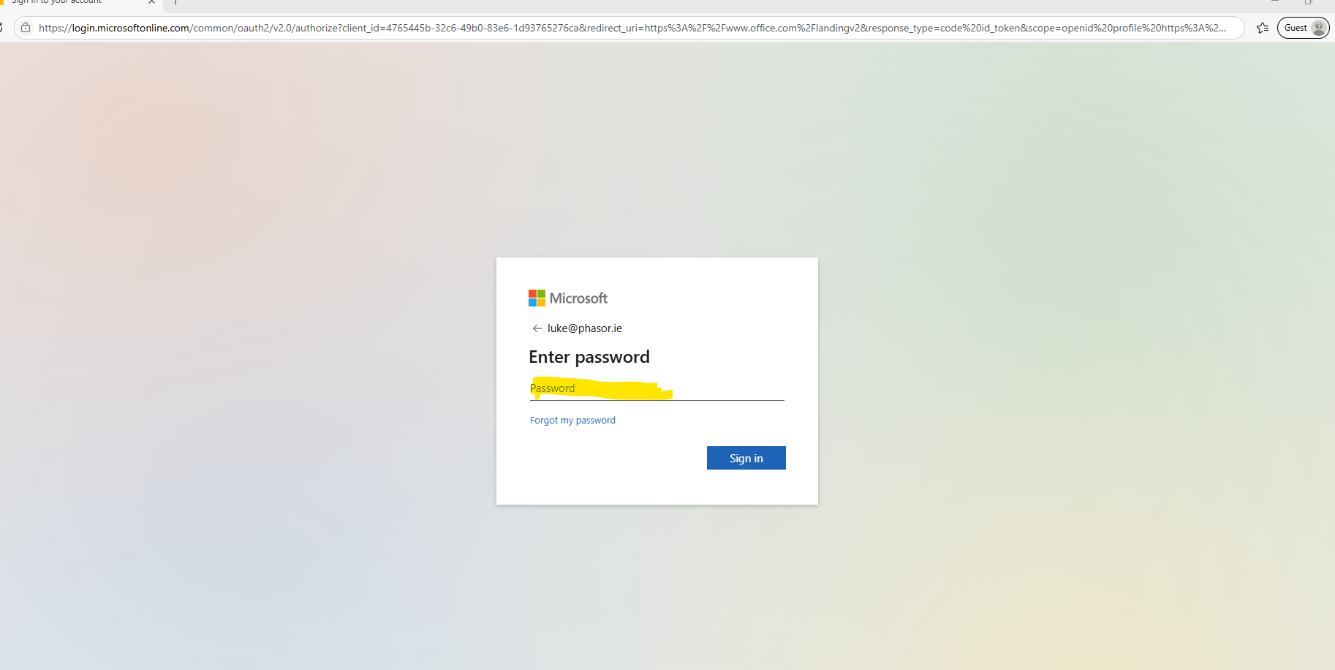

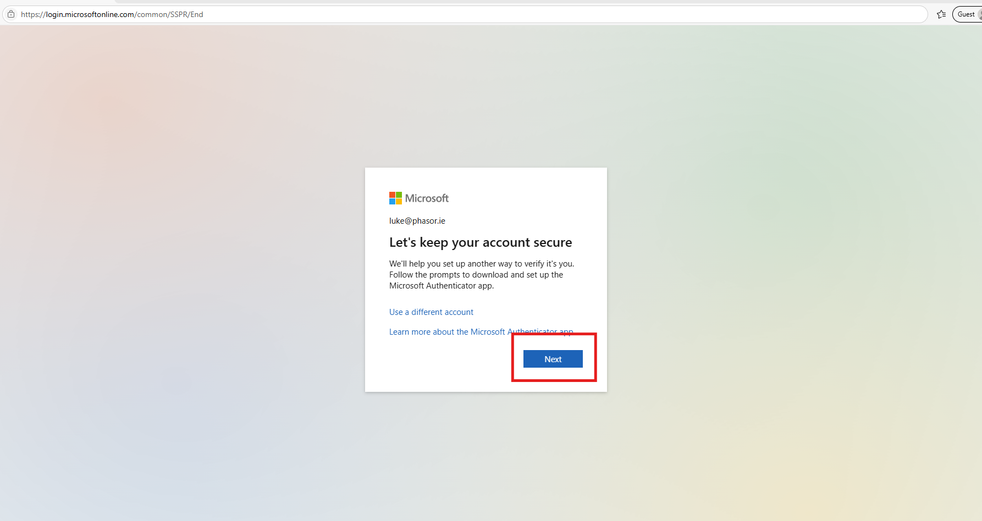

- Download the Microsoft Authenticator App to your phone ( if you have not done it already ) and click Next

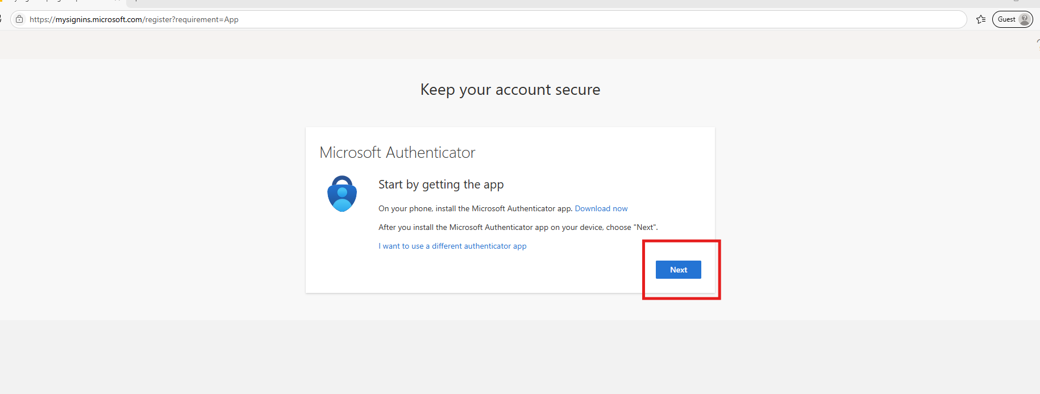

- Click Next

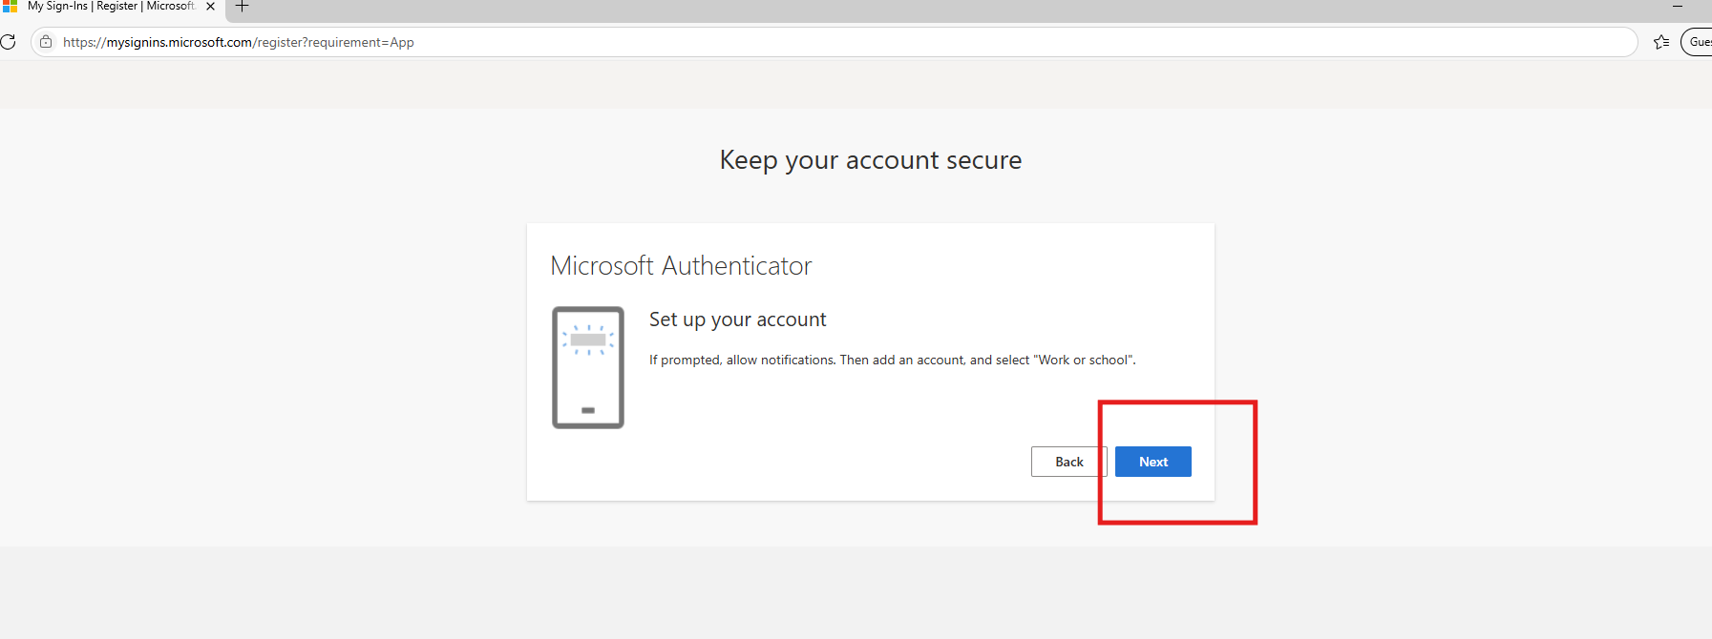

- Open the Microsoft Authenticator App and click on Add and scan the QR code that is been presented on your screen

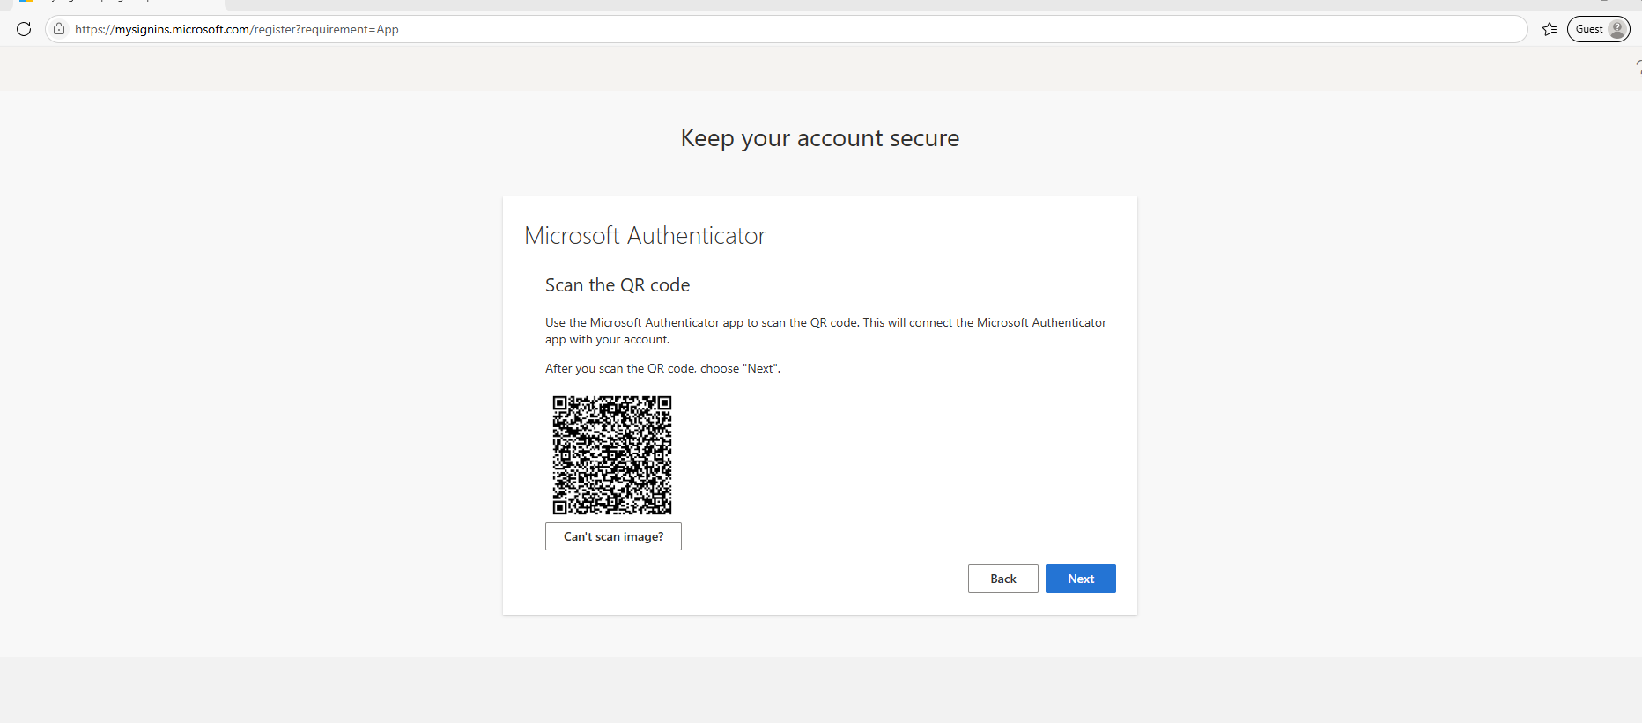

- The App will then add this account.. and when you click Next on the laptop screen.. it will show you a 2 digit code.. which you then put into the App.. which should pop up on your phone.. for you to enter it… ( you may need to enable notifications for the App on your phone )
- You will now have access to your account

